S5P4418 Filter FFMPEG Movie Player API for Android
Version 0.85.0(alpha2)
Copyright © 2014 Nexell Co.,Ltd. All rights reserved.
S5P4418 Filter Movie Player API for Android
Nexell S/W Team 3
Release information
The following changes have been make to this document.
Change History
Date | Change
1 December 2014 | First release for v0.85.0(alpha2)

Proprietary Notice
Information in this document is provided solely to enable system and software implementers to use Nexell products. There are no express or implied copyright licenses granted hereunder to design or fabricate any integrated circuits or integrated circuits based on the information in this document.
Nexell reserves the right to make changes without further notice to any products herein.
Nexell makes no warranty, representation or guarantee regarding the suitability of its products for any particular purpose, nor does Nexell assume any liability arising out of the application or use of any product or circuit, and specifically disclaims any and all liability, including without limitation consequential or incidental damages. “Typical” parameters which may be provided in Nexell data sheets and/or specifications can and do vary in different applications and actual performance may vary over time. All operating parameters, including “Typicals” must be validated for each customer application by customer’s technical experts. Nexell does not convey any license under its patent rights nor the rights of others. Nexell products are not designed, intended, or authorized for use as components in systems intended for surgical implant into the body, or other applications intended to support or sustain life, or for any other application in which the failure of the Nexell product could create a situation where personal injury or death may occur. Should Buyer purchase or use Nexell products for any such unintended or unauthorized application, Buyer shall indemnify and hold Nexell and its officers, employees, subsidiaries, affiliates, and distributors harmless against all claims, costs, damages, and expenses, and reasonable attorney fees arising out of, directly or indirectly, any claim of personal injury or death associated with such unintended or unauthorized use, even if such claim alleges that Nexell was negligent regarding the design or manufacture of the part.

Copyrightⓒ 2009~2014 Nexell Co.,Ltd. All rights reserved.
No part of this publication may be reproduced, stored in a retrieval system, or transmitted in any form or by any means, electric or mechanical, by photocopying, recording, or otherwise, without the prior written consent of Nexell.

Contact us
[463-825] Bundang yemizi Bldg. 1202, 6-5 Sunae-dong, Bundang-gu, Sungnam-city, Gyeonggi-do, Korea.
TEL: 82-31-698-7400
FAX:82-31-698-7455
http://www.nexell.co.kr

Contents
Chap 1. Overview 2
1.1 Overview 2
1.2 지원범위 2
1.3 Environment 3
Chap 2. APIs 4
2.1 Overview 4
2.2 API Details 4
Chap 3. State Diagram 9
3.1 Media Player State Diagram 9
Chap 4. History 10
Change History 10
Chap 5. Known Issues 11
5.1 To Do List 11
5.2 Known Bug 11

Overview

Overview
이 문서는 S5P4418 Android 환경에서 Filter Library을 사용하여 각종 동영상 및 음악 파일을 재생하기 위한 API의 사용법을 설명한 문서이다.

지원범위

Container

Movie Container
- ASF, AVI, MKV, MP4, RM(RealMdeia), FLV, MPEG-PS, MPEG-TS

Audio Container
- Mp3, flac, aac, flac, ogg, wav, wma

Video Codec
- H.264 : 1920x1080, 30fps
- H.263 : 1920x1088, 30fps
- MPEG2: 1920x1080, 30fps
- MPEG4: 1920x1080, 30fps
- FLV: 1920x1080, 30fps
- RealVideo: 1920x1080, 30fps
- VC1(WMV9): 1920x1080, 30fps
- Theora: 1280x720, 30fps

Audio Codec
- MP3 : ~48KHz, ~320Kbps, 2Ch
- AAC : ~96KHz, ~320Kbps, 5.1Ch
- AC3 : ~48KHz, ~256Kbps, 5.1Ch
- OGG : ~48KHz, 2Ch
- RealAudio : ~48KHz, ~256Kbps, 2Ch
- WMA : ~48KHz, ~192Kbps, 2Ch
- FLAC : ~96KHz, 2Ch
- PCM : ~96KHz, 2Ch
- DTS : ~96KHz, ~256Kbps, 5.1Ch
- COOK ; ~48KHz, ~256Kbps, 2Ch

Environment
이 API의 동작 환경은 다음과 같다.
- S5P4418 D/Q
- Linux Kernel Version 3.4.39
- FFMPEG(Ver: 2.1.4).
(hardware/samsung_slsi/slsiap/apps/NxPlayerBasedFilter/jni/libs)
- Filter library.
  - “libNX_FILTER.so”
(hardware/samsung_slsi/slsiap/apps/NxPlayerBasedFilter/jni/libs)

APIs

Overview
API 에 대한 세부 설명이다.

API Details

NX_MPSetFileName
Description:
This function creates the memory,initializes the handle.
Prototype:
MP_RET NX_MPSetFileName( MP_HANDLE *handle, const char *uri ,
MEDIA_INFO *media_info ,
);
Parameters;
MP_HANDKE handle : Movie player handle (input/output).
const char *uri : File name or URL. (input)
MEDIA_INFO *media_info : media info handle (output)
Return value:
-1: Error
-2: Audio Codec Not Support
-3: Video Codec Not Support
-4: Audio,Video Codec Not Support

NX_MPOpen
Description:
This function creates the memory,initializes the handle.
Prototype:
MP_RET NX_MPOpen( MP_HANDLE *handle,
int select_audio_track_num, int select_video_track_num, , int pip,
void *pSurface_1, void *pSurface_2, void *pNull,
void(*cbEvent)(void *Obj, uint32_t EventType, uint32_t EventData, uint32_t parm), void *cbPrivate)
Parameters:
MP_HANDKE handle : Movie player handle (input/output).
int select_audio_track_num: audio track number. (input) : select track number(in case MultiTrack)
int select_video_track_num : video track number (input): select track number(in case MultiTrack)
int32_t pip: pip . OFF➔0, ON➔1
void *pSurface_1: Window Pointer (input)
void *pSurface_2: Window Pointer (input)
void *pNull: NULL
void (*cbEvent) :callback function(input) : End Of Stream, Error 가 발생했을 때 callback function 을 통해 EOS, Error 메시지가 전달된다.
void *cbPrivate: callback private data

Return value:
Error Code.

enum{
ERROR_NONE = 0,
ERROR = -1,
ERROR_HANDLE = -2,
}; //ErrorCode

NX_MPClose
Description:
This function frees the memory.
Prototype:
void NX_MPClose( MP_HANDLE handle );
Parameters:
MP_HANDLE handle: Movie player handle (input/output)
Return value:
None.

NX_MPGetMediaInfo
Description: Media Information
This function gets media information.
Prototype:
MP_RESULT NX_MPGetMediaInfo(
MP_HANDLE handle, (input/output)
int index, (input)
MP_MEDIA_INFO *pInfo (output) );
Parameters:
MP_HANDLE handle: Movie player handler.
int index : Media index.
MP_MEDIA_INFO *pInfo : 해당 index에 따른 media information.
Return value:
If exist media information for each indexes, return ERROR_NONE. Otherwise return ERROR.

typedef struct _Media_Info{
int32_t AudioTrackTotNum;
Audio_Info AudioInfo[MEDIA_MAX];
int32_t VideoTrackTotNum;
Video_Info VideoInfo[MEDIA_MAX];
int32_t DataTrackTotNum;
int64_t Duration;
} Media_Info

NX_MPPlay
Description:
This function starts the play.
Prototype:
MP_RESULT NX_MPPlay( MP_HANDLE handle, float speed );
Parameters:
MP_HANDLE handle: Movie player handler. (input)
float speed : playing speed. The value 1.0 means normal speed. (other value not support yet)
(This functionality is not available yet.)
Return value:
If success returns ERROR_NONE, otherwise returns ERROR.

NX_MPPause
Description:
This function pauses the play.
Prototype:
MP_RESULT NX_MPPause(MP_HANDLE hande);
Parameter:
MP_HANDLE handle: Movie player handler.(input)
Return value:
If success returns ERROR_NONE, otherwise returns ERROR.

NX_MPStop
Description: Media
This function stops the play.
Prototype:
MP_RESULT NX_MPStop(MP_HANDLE hande);
Parameter:
MP_HANDLE handle: Movie player handler. (input)
Return value:
If success returns ERROR_NONE, otherwise returns ERROR.

NX_MPSeek
Description:
This function seeks the play.
Prototype:
MP_RESULT NX_MPSeek(MP_HANDLE hande, unsigned int seekTime);
Parameter:
MP_HANDLE handle: Movie player handler. (input)
unsigned int seekTime: Seek time in milli-seconds. (input)
Return value:
If success returns ERROR_NONE, otherwise returns ERROR.

NX_MPGetCurDuration
Description:
This function gets media duration.
Prototype:
MP_RESULT NX_MPGetCurDuration(MP_HANDLE handle, unsigned int *duration)
Parameters:
MP_HANDLE handle: Movie player handler. (input)
unsigned int *duration: Contents duration in milli-seconds. (output)
Return value:
If success returns ERROR_NONE, otherwise returns ERROR.

NX_MPGetCurPosition
Description:
This function gets current position.
Prototype:
MP_RESULT NX_MPGetCurPosition(MP_HANDLE handle, unsigned int *position)
Parameters:
MP_HANDLE handle: Movie player handler. (input)
unsigned int *position: Current play time in milli-seconds. (output)
Return value:
If success returns ERROR_NONE, otherwise returns ERROR.

State Diagram

Media Player State Diagram

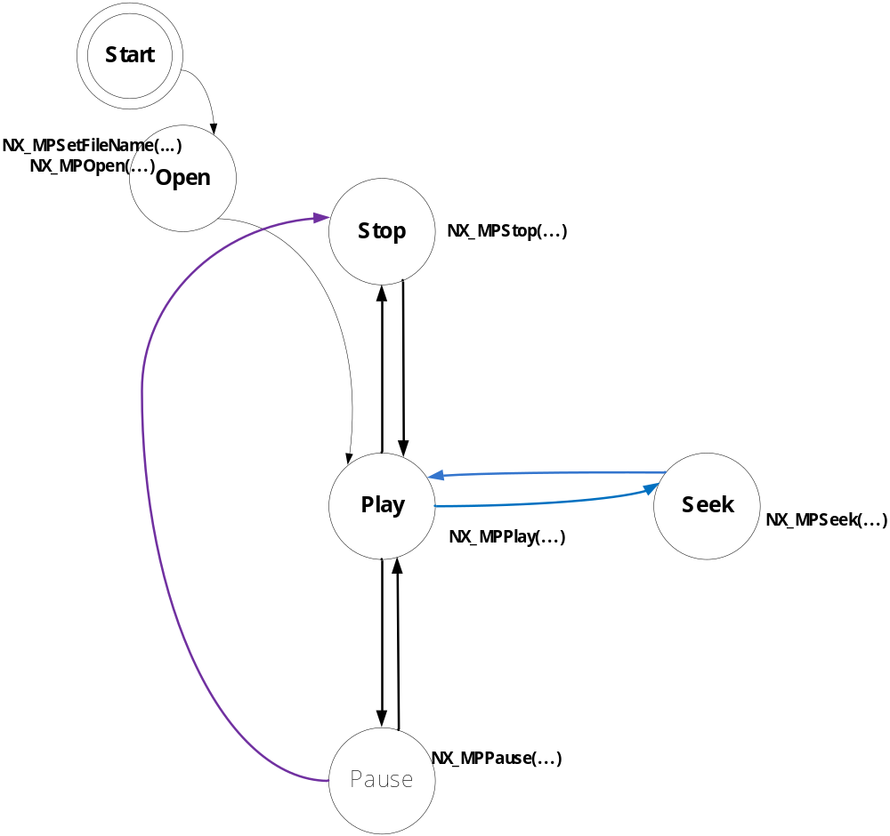

History

Change History

Change history
Date | Subject/Comment | Old | New
2014-12 | A/V Sync |  | 0.85.0(alpha2)
2014-12 | Filter Movie Player API for Android |  | 0.8.0(alpha)

Known Issues

To Do List
- Pause ➔ Seek

Known Bug

1. | Seek 정상동작 안함
2. | (Video + Audio) Audio 가 Ogg 인 경우TimeStamp 정확하지 않아서 Audio, Video 가 끊어짐.
3. | Audio 가 1 frmae 안에 여러 개의 프레임이 들어가 있는 경우 TimeStamp 가 정확하지 않아서 A/V 가 끊어짐.

